Esteban Aranda

CS 4341

10/06/19

Project 6: Bayesian Networks

The following tables display the data gathered from running each sampling method 10 times, and their respective mean and variance. The number-letter combinations represent the network and query respectively.

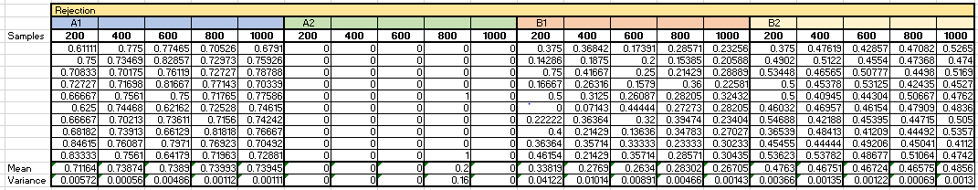Rejection Sampling table:

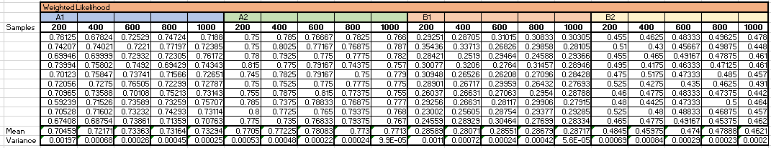Weighted Likelihood table:

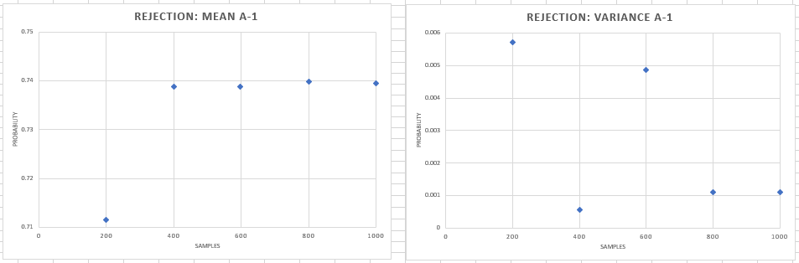Using the mean and variance from the tables we can then plot them against each other for each to see the general trends as the number of samples increase.

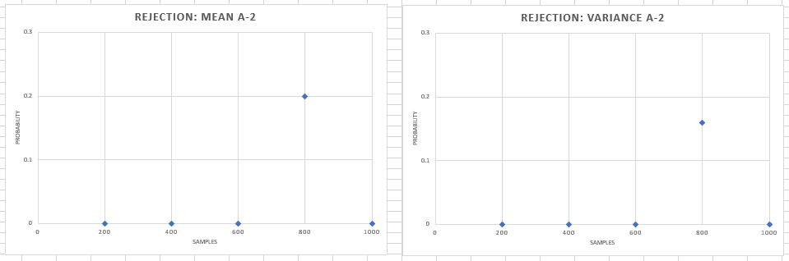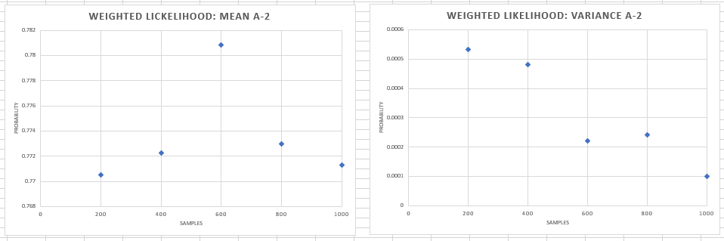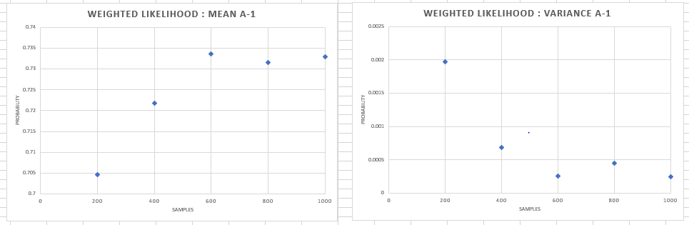For Network A – Query 1 it can be seen that for both methods the general trends of the means is that they have a relatively small value when the number of samples is 200, but this quickly increases as the number of sample increases and the values of the means start to converge around 0.74. As for the variance, the general trend for both methods is that the variance decreases as the number of samples increase, with some outliers. Given that the mean for 1000 samples for both methods result in close numbers we can assume they are reliable and are close to the “true” probability. It also appears that in this case, rejection sampling converged faster to the probability of 0.74 as the means started to very closely fluctuated around that value as soon as 400 samples were used. On the other hand, the variance between the means for weighted likelihood are much higher, therefore we can say that it is converging at a slower rate. This could be explained because Query 1 in Network A could be a very frequently occurring scenario and thus when using rejection sampling, we get a lot of samples that match the evidence and thus can quickly get an accurate result.

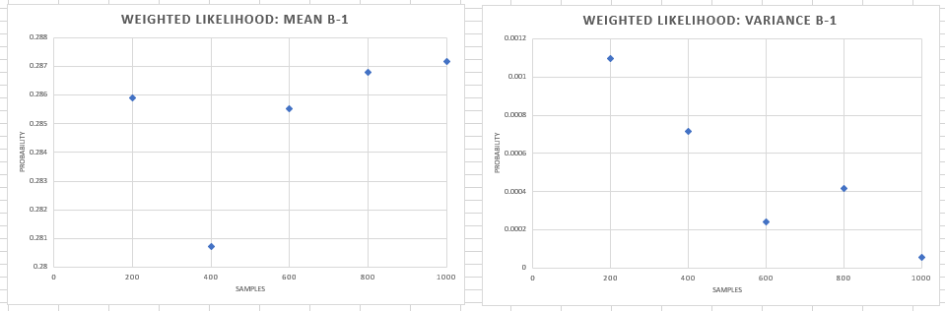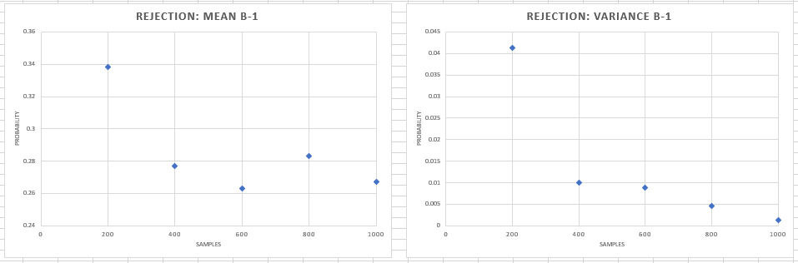For Network A – Query 2 there is a huge difference between both methods. The means and variance for rejection sampling are all 0 save for the case with 800 samples. On the other hand, the means obtained from weighted likelihood sampling hover around 0.77. And, for the variance, the general trend is that it decreases as the number of sample increases. The result is that we have two extremely different results. This is because the probability of the evidence variables in Query 2 occurring in Network A appear to be extremely small, and thus with rejection sampling we get unreliable results. On the other hand, we can assume that the results from the second method are somewhat reliable because weighted likelihood allows us to calculate probabilities accurately even in scenarios like this. Clearly, weighted likelihood sampling is the method that converges to the probability of around 0.77 faster. Even though the there is a spike in the mean of 600 samples, the variance is continually decreasing. Given that the variance for 1000 samples is only 0.00001, we can be certain that the result is accurate and even with more samples the probability would only differ slightly.

For Network B – Query 1 the means between the two methods do not differ much, but the trends do. For rejection sampling, the general trend is that the mean decreases as the number of samples increases. Comparatively, for weighted likelihood sampling the means slightly increase with the number of samples. For the variance for both sampling methods, the general trend is that they decrease with the number of samples. Given that the variances obtained from weighted likelihood sampling are much smaller and all means hover around 0.28, we can conclude that this method leads to convergence faster. On the other hand, for rejection sampling there is higher variance overall and more fluctuation between the means from around 0.26 to 0.28. This could be because the probabilities for the evidence variables in Query 1 being present in Network B are somewhat low and thus results with rejection sampling are not as accurate as weighted likelihood, which quickly converges to a probability.

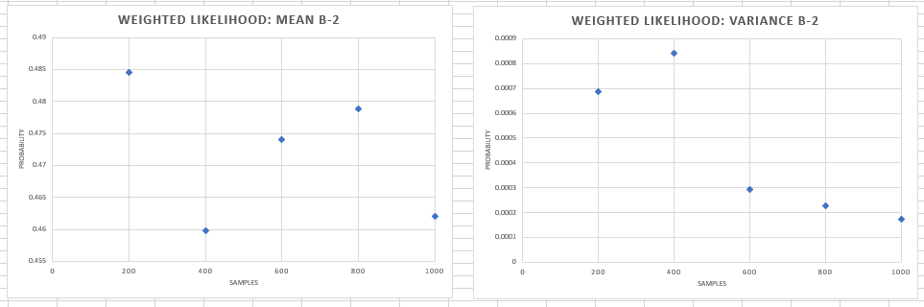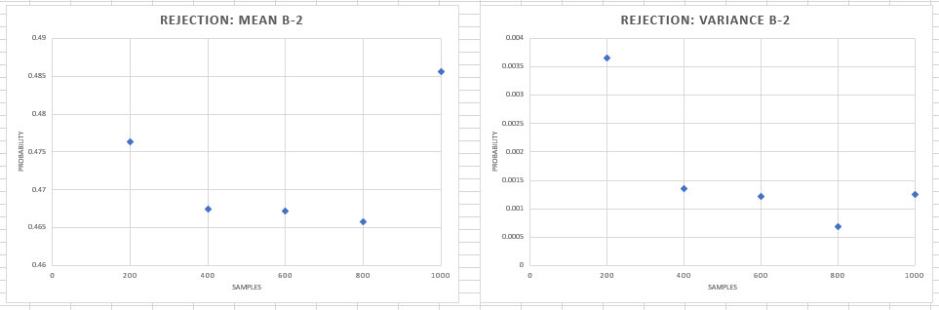Finally, for Network B – Query 2 there does not seem to be much of a trend for the means in both cases. The overall trend of the variances is that they decrease as the number of samples increase, but thus is not true for rejection sampling with 1000 samples and weighted likelihood sampling with 400 samples. Given that the variances for the second sampling method are lower, we can conclude that it is converging faster to the probability of around 0.46. We can confirm with the values from rejection sampling, which before the mean of 1000 samples jumping to 0.48, were fluctuating around 0.46 too and with low variance. Overall both methods seem to be relatively close to one another in this case because the means for rejection sampling were more closely fluctuating around 0.46 at a faster rate, but the values from weighted likelihood sampling had smaller variance. We can conclude that the evidence variables of Query 2 occur moderately in Network B, and thus both sampling methods are reliable sources to obtain the probability of the query. As for the spike in rejection sampling for 1000 samples, it seems to be an outlier as the variance also increased in that case.